**Lab 9**

1. **[5] Produce a wait-for-graph for the following transaction scenario and determine whether deadlock exists.**

|  |  |  |
| --- | --- | --- |
| **Transaction** | **Data Items locked**  **by Transaction** | **Data items transaction is waiting for** |
| T1 | x2 | x1, x3 |
| T2 | x3, x10 | x7, x8 |
| T3 | x8 | x4, x5 |
| T4 | x7 | x1 |
| T5 | x1, x5 | x3 |
| T6 | x4, x9 | x6 |
| T7 | x6 | x5 |

Ans:-

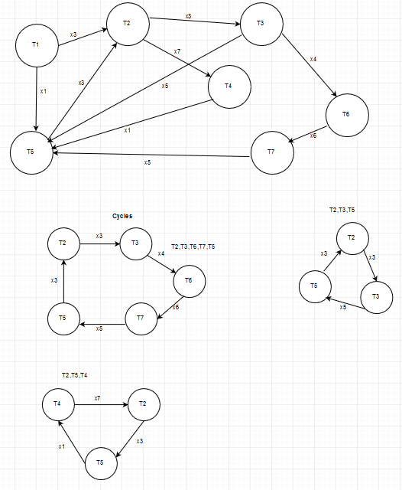

**2. [5] Consider the following sequence of actions, listed in the order the actions are presented to the DBMS.**

**T1: R(X), T2: W(X), T2: W(Y), T3: W(Y), T1: W(Y), T3:R(Z), T3:W(Z), T1: Commit, T2: Commit, T3: Commit**

**Assume that the concurrency control mechanism is 2PL with “Wound-Wait” deadlock prevention strategy.   
Acquire locks as late as possible and release locks as early as possible. Waiting transactions continued and brought up to date as early as possible.  
Describe how the concurrency control mechanism handles the sequence of actions.**